Educational Administration: Theory and Practice
2024,30(2), 467-482
ISSN:2148-2403
https://kuey.net/ Research Article

Big Data Analytics, AI And ML In Business: Redefining Strategic Frameworks, Marketing Strategies, Organizational Structures, And Operational Efficiency

Sanjay Vaid^{1*}, Dr. Ashish Kumar², Dr. Priyanka Yadav³

¹Ph.D. Research Scholar, Department of Commerce & Management, Starex University
²Assistant Professor, School of Business, Sushant University, Gurugram
³Assistant Professor, Department of Commerce & Management, Starex University, Gurugram

Citation: Sanjay Vaid et al. (2024), Big Data Analytics, AI And ML In Business: Redefining Strategic Frameworks, Marketing Strategies, Organizational Structures, And Operational Efficiency, Educational Administration: Theory and Practice, 30(2), 467-482
Doi: 10.53555/kuey.v30i2.1334

ARTICLE INFO | ABSTRACT
The business landscape has been transformed by the emergence of technologies such as Artificial Intelligence (AI), Machine Learning, Big Data Analytics, and Natural Language Processing. This has made the Information Technology (IT) function an integral part of the business model rather than just a support function. As a result, the usage of technology is now driven by various functions beyond IT, including Marketing, Human Resources, Operations, Finance, and Legal. This phenomenon is referred to as Shadow IT, and its implications are explored in this paper. The paper examines how the intersection of AI, ML, Big Data Analytics, NLP, and Shadow IT is transforming business paradigms and functions such as Marketing, Operation, and Organization structure. The study is conducted through a literature review, case studies, and an analysis of various industry sectors. Finally, the paper concludes with a discussion of the findings and recommendations for future research in this area.

Keywords: Artificial Intelligence, Machine Learning, Big Data Analytics, Natural Language Processing, Shadow IT, Value Train, Value Chain, 8 Ps of Marketing, Organization structure, Ethics.

Big Data Analytics, AI And ML In Business: Redefining Strategic Frameworks, Marketing Strategies, Organizational Structures, And Operational Efficiency

The paper explores the role of Big Data Analytics, Artificial Intelligence (AI), Machine Learning (ML), and Natural Language Programming (NLP) in transforming business. The further paper also explores during the stages of transitioning the concept of Shadow IT, in which various department leverage AI, ML, NLP, and Data Analytics in silos which have traditionally been seen as Information technology (IT) department work, which bring its own set of challenges and benefits. The paper delves into the impact of technological advancements on various aspects of business such as operations, marketing, strategy, and organizational design. It examines how organizations and businesses will transform in terms of structure and function in the future.

Introduction

In the ever-evolving landscape of business, the incorporation of technology has become a constant. The dawn of the 21st century bore witness to unprecedented advancements in the field of technology, creating an intricate nexus of opportunities for businesses worldwide (West & Bonnet, 2015). Innovations such as Artificial Intelligence (AI), Machine Learning (ML), Big Data Analytics, Natural Language Processing (NLP), and Shadow IT have significantly altered the way businesses operate, often disrupting established norms to institute an entirely new paradigm of operation (Kane, Palmer, Phillips, Kiron & Buckley, 2015).
The purpose of this research is to critically examine the intersection of these quintessential elements of the modern technological revolution - AI, ML, Big Data Analytics, NLP, and Shadow IT - and analyze their impacts on transforming contemporary business paradigms. Artificial Intelligence (AI), as an umbrella term, represents the simulation of human brain functions by machines, especially computer systems, and includes tasks such as learning, reasoning, problem-solving, perception, and language understanding (Russell, Norvig, & Artificial Intelligence, 2016). Machine Learning (ML), a subset of AI, involves the use of statistical techniques to enable machines to improve their performance over time through experiences (Mohri, Rostamizadeh, & Talwalkar, 2018).
Big Data Analytics refers to the complex process of analyzing large and varied data sets, or 'big data', to uncover information such as hidden patterns, insights, and correlations, helping to make informed business decisions (Chen, Chiang, & Storey, 2012).
Natural Language Processing (NLP) is an AI methodology that enables computers to understand, interpret, and generate human language in a valuable way (Bird, Klein, & Loper, 2009).
Lastly, Shadow IT, an emergent phenomenon in many organizations, represents IT devices, software, and services, outside the ownership or control of the IT department (Kavis, 2014). Each of these components, wired in the right systematic infrastructure, holds the potential to catalyze advancements in the business world.

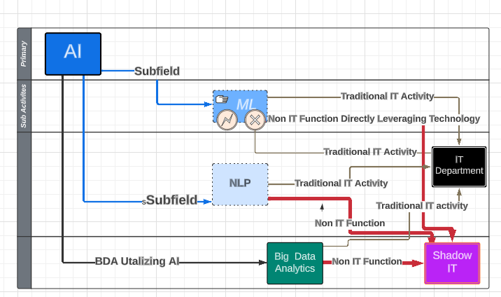
Figure 1 Relationship and flow between AI, ML, NLP, Big data, and Shadow IT.

The research also explores how the traditional strategic business models have been transformed, once such model in Prof. Micheal Porter's Internal Value chain. The sequence of activities a company performs to design, produce, sell, deliver, and support its product is called the value chain; in turn, a company's value chain is part of a larger value chain. (Margretta, 2012) The traditional value chain is also affected by technology changes. The research explores the effect of changes in technology on the framework through our literature review.

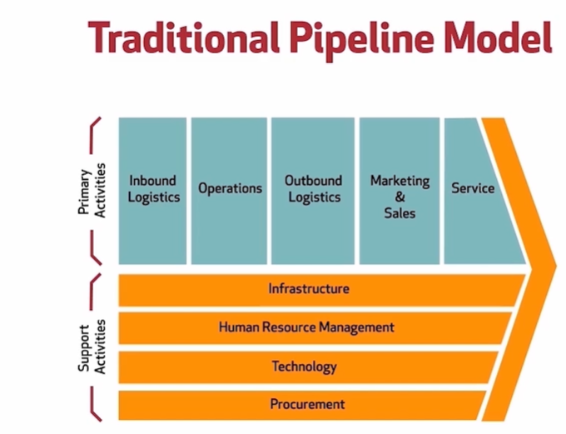
Figure 2 Porter Value Chain.

The 4 P’s of Marketing (product, price, place, and promotion) are fundamental concepts that businesses use to develop marketing strategies. However, in today's digital age, technological advancements such as Big Data Analytics, AI, ML, NLP, and Shadow IT have had a significant impact on the way companies approach marketing. This research paper delves deeper into the influence of these technologies on the 4 P’s of Marketing. The paper aims to provide a comprehensive analysis of how AI, ML, NLP, and Shadow IT are altering the marketing landscape and the implications of these changes for businesses.

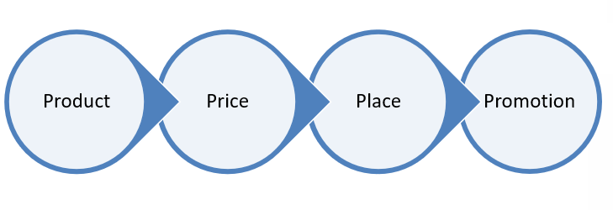
Figure 3 The Four P's of Marketing.

The primary objective of the research is to delve into the intricacies of how emerging technologies such as Artificial Intelligence (AI), Machine Learning (ML), Natural Language Processing (NLP), and Shadow IT influence the traditional organizational structures. The research further aims to examine how these technological advancements can potentially impact the existing matrix and functional organizational structures, and what the future organizational structures may look like.

Literature Review

The influx of Artificial Intelligence (AI), Machine Learning (ML), Big Data Analytics, Natural Language Processing (NLP), and Shadow IT reflects an ongoing transformation in the business world. The convergence of these technologies has instigated a paradigm shift in business practices and operations. This literature review will focus on each technology's unique role and potential impacts on business paradigms.

Artificial Intelligence (AI) in Business
AI has emerged as a crucial component in the digital transformation process of businesses (Sivarajah, Kamal, Irani, & Weerakkody, 2017). The technology has been successfully deployed across various business functions, such as customer service, logistics, and supply chain management, providing decision-making capabilities beyond traditional rule-based systems (Brynjolfsson & Mcafee, 2014).

Figure 4: Conceptual Model on the Creation of Competitive Advantage through the Development of Synergies in Business with Big Data Analytics.

Competitive advantage refers to the process by which a firm creates a strategic advantage that generates value and is not easily replicated by its current or future competitors. This is according to Barney (1991) and Galleti & Papadmitriou (2013). To analyze the development of competitive advantages through marketing and big data analytics, we used a conceptual model that emphasizes compatibility and integration. This model highlights four competitive advantages, namely: value, rarity, inimitability, and non-substitutability, as shown in Figure 2.
For instance, AI can leverage customer data to predict behaviors and preferences, allowing businesses to provide hyper-personalized experiences (Huang & Rust, 2018). Companies like Amazon and Spotify are renowned examples of businesses that use AI to drive personalized recommendations, which enhance user engagement, thereby providing them with a significant competitive edge (Boyd & Crawford, 2012).
Artificial intelligence (AI) has stimulated considerable attention from academia and industry (Dignum, 2017). Its application in business ranges from decision-making processes, and customer relationship management, to automation and efficiency enhancement (Lu, 2018). Capitalizing on AI's predictive and prescriptive analytics capabilities facilitates more accurate forecasting and strategies, making it a powerful ally in business decision-making (Chui, 2018).

Machine Learning (ML) in Business
Machine Learning, a subset of AI, is another significant technological force driving business transformation. Through ML algorithms, businesses can model complex, high-dimensional datasets and make predictive decisions, impacting their bottom line positively (Alpaydin, 2020). In the financial sector, ML is being used extensively in credit risk modeling, fraud detection, algorithmic trading, etc. (Biais, Bisière, Bouvard, & Casamatta, 2019). For instance, JPMorgan Chase uses ML to expedite the contract reviewing process, which used to take their lawyers 360,000 work hours annually, an explicit demonstration of work process streamlining and efficiency improvement through ML (Raghupathi & Raghupathi, 2014).

Machine learning (ML) extends the capabilities of AI by allowing systems to learn and improve automatically from experience (Jordan & Mitchell, 2015). Companies that use ML may improve their operations and decision-making by extrapolating complicated trends and patterns from data they already have (Brynjolfsson & McElheran, 2016).

Big Data Analytics in Business
Big Data Analytics is a paramount frontier that businesses are harnessing for strategic decision-making. The ability to analyze vast amounts of structured and unstructured data offers businesses unprecedented insights, drives innovation, enhances efficiency, and leads to improved customer experiences (Chen, Chiang, & Storey, 2012). Telecommunication companies like Vodafone have harnessed big data analytics to reduce churn rates by predicting customer behavior (Gupta & George, 2016). Similarly, retailers such as Walmart use big data analytics to optimize inventory and increase sales, demonstrating immense applicability across business domains (McAfee, Brynjolfsson, Davenport, Patil, & Barton, 2012).
Advocates argue that Big Data Analytics, through pattern recognition, predictive analysis, and statistical algorithm implementation, helps businesses garner insights that drive profitable business actions (Waller & Fawcett, 2013).

Natural Language Processing
Natural Language Processing (NLP), another AI field, facilitates understanding, interpreting, and manipulating human language by machines, thereby allowing a more intuitive human-machine interaction (Hirschberg & Manning, 2015). Businesses harnessing NLP witness improved customer service, sentiment analysis, and business intelligence through greater semantic understanding (Cambria & White, 2014).
Natural Language Processing (NLP) has made significant strides in the last decade, with advancements driven primarily by machine learning techniques, especially deep learning. These developments have enabled computers to comprehend, generate, and even translate human language with impressive accuracy (Goldberg, 2017). NLP is a pivotal element in numerous applications such as virtual assistants, translation services, sentiment analysis, and much more. It is empowering the next generation AI systems to understand and interact in human language, thereby providing more intuitive and enhanced user experiences (Hirschberg & Manning, 2015). The evolution and potential of NLP cannot be discussed without acknowledging the remarkable contributions made by models like BERT, GPT-3, and GPT-4.
These models have significantly elevated the NLP applications' performance by better understanding contextual relationships between words and long texts. They have also unlocked new potentials in language tasks such as speech recognition, speech generation, machine translation, and natural language understanding. Despite the immense progress, challenges remain, particularly involving the interpretability, robustness, and ethical implications of these AI-driven language systems (Strubell, Ganesh, & McCallum, 2019).

Shadow IT
Shadow IT, an area of technology misaligned with or hidden from an organization's IT controls, presents a growing concern as businesses evolve digitally. It involves the use of technology devices, software, and services outside of and without direct authorization from a company’s IT department. While it allows for more organizational agility and may boost productivity, it also typically circumvents security protocols and can lead to data breaches, compliance issues, and hidden costs (Renner, Behrens, & Krcmar, 2014). As companies shift towards digital and cloud-based solutions, Shadow IT usage has surged, and the trend is expected to continue. A study by Rodrigues, Costa, and Oliveira's (2018) found that several factors contribute to this escalation, such as inadequate provision of IT resources, speed of technological change, and unmet end-user needs. With these challenges, it is argued that it would be more beneficial to govern rather than completely eliminate Shadow IT (Veiga, Kvasny, & Warren, 2014).
Despite the numerous advantages of the aforementioned technologies, the rise of Shadow IT poses significant hurdles. Shadow IT refers to the unsanctioned IT resources used within an organization, which often lead to data security concerns and governance issues (Behl &, Ferreira, 2018). Yet, it presents opportunities for innovation and rapid problem-solving outside of traditional organizational structures (Koppers, 2019).
Artificial Intelligence has use cases in various business functions such as Marketing, Operations, HR, Finance, and Legal. It makes these functions more efficient, effective, and agile, resulting in increased competitiveness in the market.(Bertone et al.)
In conclusion, the intersection of AI, ML, Big Data Analytics, NLP, and Shadow IT has the potential to transform business paradigms. It enhances decision-making processes, automation, efficiency, customer service, and innovation. However, it is crucial to manage the security concerns associated with Shadow IT effectively.

Conceptual Framework:

Technology has transformed the banking industry, with AI, ML, Big Data Analytics, NLP, and Shadow IT redefining traditional banking paradigms. This chapter explores how these technologies intersect and revolutionize banking. AI has emerged as a rising star, captivating diverse sectors, particularly the banking industry. The significant role of technology in this evolution cannot be understated. Subsequent milestones, from Internet banking to mobile banking and now, services empowered by AI and RPA – Robotic and process substantially reshaped banking operations.
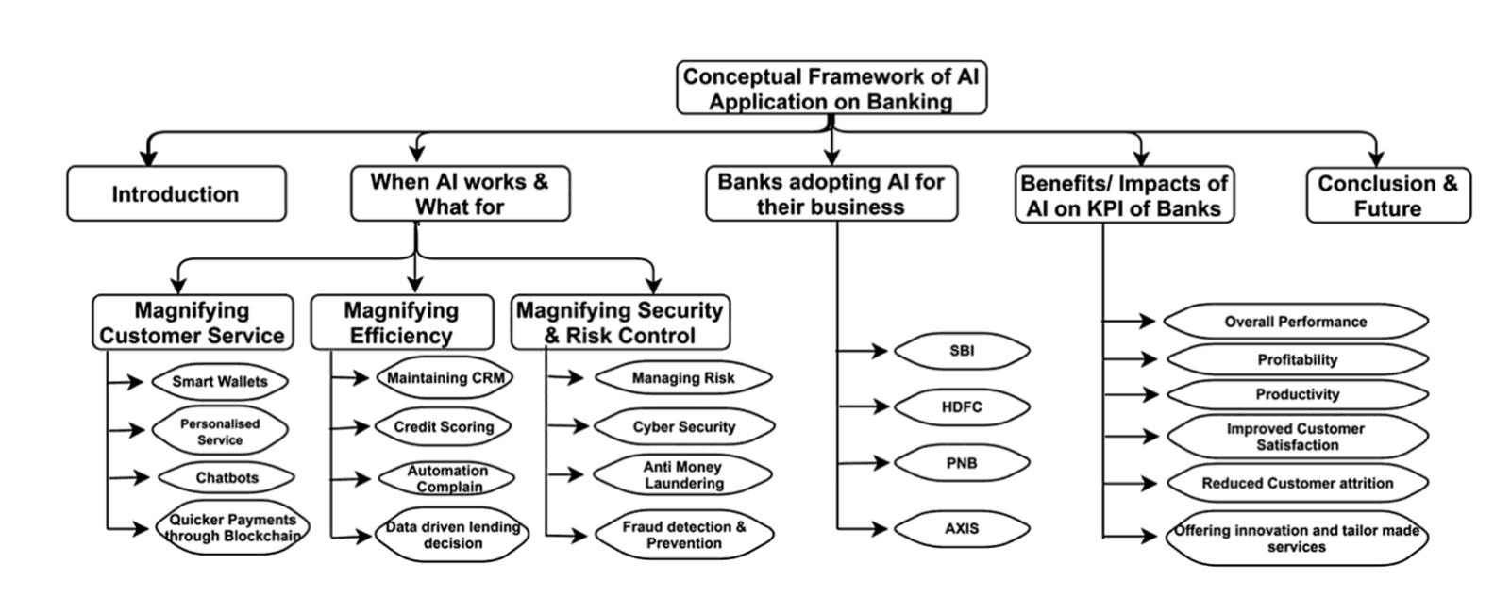
Figure 5 Conceptual Framework of AI in the Banking sector (Source: Artificial Intelligence and Machine Learning in Business Management, Volume 1)

The banking industry is changing fast due to increased demand for better connectivity with finances which has fueled the emergence of digital banking backed by AI. Banks need to embrace these new forms of customer interaction and leverage AI and ML to simplify complex operations. This chapter explores the benefits of AI and ML in banking.

The internet has provided us with quick access to abundant information, leading to massive data volumes and unstructured data. Augmented Intelligence bridges the gap by making pertinent information accessible for informed decision-making. AI is designed not to replace human expertise but to expand human capabilities and execute tasks that neither humans nor machines could accomplish independently. Indian banks have been early adopters of AI compared to other sectors, using it for several operations such as online and mobile banking, phone banking, mail services, and mobile banking. AI's integration has contributed to enhanced operational efficiency, cost-effectiveness, and improved customer service.

AI in the Banking Sector: Where It Works and What For
AI has transformed the Indian banking sector, revolutionizing customer service, risk management, operations, and regulatory compliance. Banks are using innovative AI technologies to gain a competitive edge.

Customer Service and Chatbots

Banks prioritize enhancing customer service. AI chatbots play a crucial role in achieving this goal by providing real-time assistance with banking queries. Indian banks use chatbots to provide instant responses, streamline processes, and reduce operational costs. Chatbots continuously learn and improve responses by analyzing historical customer interactions, improving customer satisfaction over time.

Fraud Detection and Prevention

AI is an effective tool for detecting and preventing fraud. Machine learning models analyze transaction data in real-time to identify unusual patterns that may indicate fraudulent activities. In India, AI-driven fraud detection systems monitor transactions, assess risk factors, and trigger alerts when suspicious activities are detected, saving banks from financial losses and protecting their reputation.

Credit Scoring and Risk Assessment
Banks traditionally use credit scores and financial history to evaluate loan applicants. AI and Machine Learning have expanded credit scoring by analyzing non-traditional data sources like social media activity and online behavior. This enables banks to offer loans to a wider range of customers. Additionally, this approach ensures lending decisions are based on more accurate information and promotes financial inclusion.

Regulatory Compliance
AI simplifies regulatory compliance for banks by automating the process of monitoring and adhering to changes. It helps banks to continuously track changes in regulations, identify non-compliance, and implement corrective measures swiftly. This minimizes the risk of regulatory fines and ensures a strong reputation for compliance.

Personalized Banking
Banks need to personalize their services to meet customer expectations. AI-powered systems can analyze customer data and offer personalized product recommendations. This leads to increased customer loyalty, engagement, and retention, resulting in a greater share of the customer's wallet.

Wealth Management and Investment
AI-powered wealth management and investment platforms, often referred to as robo-advisors, have gained popularity in the banking sector. These platforms use AI algorithms to assess a customer's financial situation, risk profile, and investment goals. Based on this analysis, they recommend a diversified portfolio of investments.
Robo-advisors provide customers with cost-effective and low-burden investment solutions. They offer real-time portfolio tracking and automatic portfolio rebalancing, ensuring that investments remain aligned with the customer's goals. Indian banks have recognized the potential of robo-advisors in democratizing wealth management, enabling a broader range of customers to access professional investment advice. (Panda, et al., u.d.)

Asset and Portfolio Management
AI is used in asset and portfolio management, as banks optimize investment strategies. Machine Learning models predict market trends and identify opportunities. With AI, banks make data-driven investment decisions, leading to higher returns for clients. AI algorithms manage portfolios efficiently, considering risk tolerance and investment goals.

.Risk Assessment and Management
AI models help banks manage risk by predicting and evaluating credit, market, and operational risks. Machine Learning models predict loan defaults using financial history and economic conditions. This empowers banks to make informed decisions proactively.

Process Automation
AI and ML have transformed banking by automating processes from document verification to transaction processing. RPA and AI-powered bots handle repetitive tasks with high efficiency. Indian banks use AI in KYC, document verification, and loan processing. NLP is used to extract insights from unstructured text data and gauge public sentiment. This helps banks understand customer perceptions and make data-driven decisions to enhance services and products.

Transforming Business Paradigms:

The Intersection of AI, ML, Big Data Analytics, NLP, and Shadow IT Abstract: This research paper scrutinized the progression and aftermath of critical technologies, specifically AI, Machine Learning (ML), Big Data Analytics, Natural Language Processing (NLP), and Shadow IT, tracing their growth over time and evaluating their impact on business paradigms. An assessment of these technologies illustrated improvements in customer service, decision-making capabilities, predictive modeling, trend analysis, information handling, innovative problem-solving, and efficiency. Nevertheless, prospective issues within these systems were also identified.

Introduction: The digital revolution has stripped away traditional business paradigms, fostering a proliferation of disruptive technologies that include Artificial Intelligence (AI), Machine Learning (ML), Big Data Analytics, Natural Language Processing (NLP), and Shadow IT. These technologies have developed through distinct yet interconnected paths, fundamentally shifting how businesses operate, compete, and deliver value to customers (Bughin et al., 2017).

Part 1: The Evolution of Disruptive Technologies:
Artificial intelligence (AI) emerged from a dream of formulating machines that could think like humans, and its development has been nonlinear but consistent since the 1950s.
AI has now permeated every aspect of business, easing tasks such as sorting information, automating manual roles, and forging intelligent troubleshooting (Makridakis, 2017). Machine Learning (ML), a subset of AI, has made significant strides since its inception. Initially conceptualized by Arthur Samuel in 1959, it has stretched beyond basic sample pattern recognition and adapted to predict complex behavior, trends, and outcomes.
Powered by growing data troves, ML can now analyze big data streams, identifying trends and future outcomes with significant accuracy (Jordan & Mitchell, 2015). Big Data Analytics, driven by the explosion of accessible data, has evolved from basic descriptive analytics to sophisticated predictive and prescriptive analytics, granting businesses unprecedented insights into strategic decision-making (Chen et al., 2012).

Figure 6 The Concept-to-Campaign-to-Cash Marketing Strategy
Source: Teradata/Aprimo 2010; (Arthur, 2013)

Digital marketing involves various aspects such as content creation, media channels including email, SMS, social media, blogs, etc., search engine optimization, and a set of key performance indicators that are crucial for running a successful digital campaign. The significance of digital marketing lies in its role in big data analytics marketing, as illustrated in figure 3.
NLP, another derivative of AI, has grown from word-processor technologies to systems that interpret everyday human language, transform unstructured data into usable information, and improve human-computer interaction (Chen et al., 2019). Revolutionizing problem-solving and innovation, Shadow IT, illegal or unapproved IT within organizations, has progressed from being a shunned practice to a potential driver of innovation. It has surfaced as a tool to bypass traditional IT structures' limitations, banking on operational efficiency and rapid solutions delivery (Behrendt et al., 2019).

Part 2: Impacts on Business
Paradigms AI and NLP have ushered in noticeable improvements in customer service and decision-making capabilities. They are central to the creation of virtual agents and chatbots, rendering efficient, personalized customer experiences (Gupta et al., 2015). Moreover, they advance decision-making by automating routine chores, allowing executives to focus on strategic issues (Davenport & Ronanki, 2018).

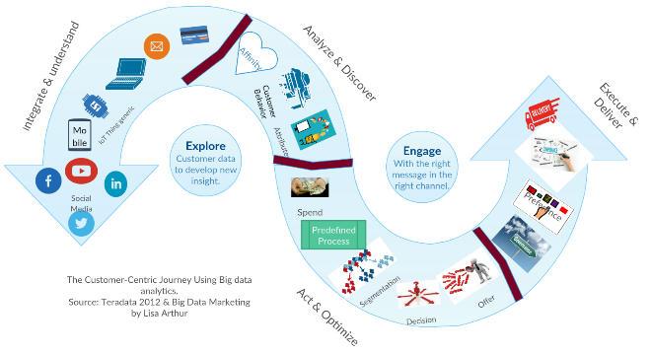
Figure 7 The customer Centric Journey using Big Data Analytics
(Arthur, 2013)

Big Data Analytics' role in business is crucial due to its capacity to handle vast quantities of structured and unstructured data for insightful decision-making (Gandomi & Haider, 2015). As illustrated in figure 2- big data collected from various sources can be analyzed to get various input make a decision and then an appropriate offer can be made to customers.
ML has led to major enhancements in predictive modeling and trend analysis, promoting advanced forecast systems and modeling tools that can predict customer behavior, market trends, and help derive strategic business decisions (Jagtap & Shiras, 2020).
Big Data Analytics has increased the capacity for information analysis and decision support, allowing businesses to extract insights from data, and guiding them to informed, evidence-based decision-making (LaValle et al., 2011).
Shadow IT has been an innovative solution source, fostering efficiency yet presenting potential issues such as data security breaches and regulatory incompliance, imposing a critical need for stringent information governance (Behrendt et al., 2019).
Conclusion: The evolution of AI, ML, Big Data Analytics, NLP, and Shadow IT is creating a new business paradigm. Regardless of the potential issues these technologies might present, their advancements have paved the way for operational efficiency, improved customer services, and strategic decision-making capabilities, transforming how businesses function.

Case Studies and Examples

Some case studies of the companies where Artificial Intelligence (AI), Machine Learning (ML), Big data analytics Natural Language Processing (NLP), has been a factor for transformation and where companies have overcome the challenges faced due to shadow IT and embrace the same in their functioning and organization design. The study analyzes the outcomes, benefits, and challenges faced while navigating this technological convergence.

Case Study One – Amazon.com, Inc.

Re-imagining the Retail Landscape through Artificial Intelligence and Machine Learning,
This paper explores the intersection of artificial intelligence (AI), machine learning (ML), big data analytics, natural language processing (NLP), and shadow IT in transforming business paradigms. Amazon.com, Inc., a colossal pioneer of e-commerce, persistently extends the limits of Artificial Intelligence (AI), Machine Learning (ML), big data analytics, Natural Language Processing (NLP), and shadow IT. Their innovative application of advanced technologies has transformed consumer interactions and experiences, transcending the traditional paradigms of online retailing (Tiwari, S., & Suri, P. K., [2023]).
Processes and Stages: To comprehend Amazon's steps towards this technological revolution, it is vital to examine several key components. Firstly, they have adeptly amalgamated AI and ML into their core infrastructure. The mechanism underlying this operation is a comprehensive analysis of their big data, fueling real-time tailor-made solutions. A practical manifestation of this onset is Amazon's recommendation system. This platform processes engagement patterns of customers, utilizing ML to analyze behavior and to propose suggestive products accordingly. Another notable application of AI through Natural Language Processing (NLP) is observed in the development of Amazon's virtual assistant, Alexa. Leveraging NLP, Alexa fosters transparent and efficient human-computer interaction, thereby broadening the realms of user-tech incorporated dialogue.
Outcomes and Benefits to the Company: With the implementation of ML and AI, Amazon has achieved extensive personalization and improved customer experiences. Patterns discerned from data analysis aid in predicting consumer preferences, which subsequently leads to precise product recommendations and improved sales (Tiwari, S., & Suri, P. K., [2023]).
Challenges and Solutions: Despite the mammoth stride taken by Amazon in enhancing its technology objectives, shadow IT has posed an accompanying set of challenges. The company grapples with managing the potential risks and ensuring compliance related to the unauthorized usage of systems, applications, and data (Dwivedi, N., & Sharma, A. [2023]). To mitigate risks associated with shadow IT, Amazon has embarked upon implementing stringent IT governance policies, investment in cybersecurity measures, and the establishing of comprehensive educational programs for employees about the risks associated with the inadvertent use of unauthorized IT resources.
Benefits to the Consumers: From the consumers' perspective, these advancements have brought about a significant transformation in their shopping experience. Enhanced product recommendations, interactive shopping through Alexa, and the secure management of data and transactions are a few of the many consumer benefits achievable through Amazon's tech integration.
Conclusion: In conclusion, Amazon's persistent innovation in AI, ML, and NLP, despite its challenges, has been the fulcrum for its stakeholder value creation. By adapting to these technologies, Amazon consistently amplifies its value proposition, underscores its role as an e-commerce leader, and sets a challenging precedent for other enterprises in the industry.

Case Study Two – Netflix, Inc.:

Title: An In-depth Investigation into Netflix, Inc. Optimizing User Experience through Advanced Analytics and Al-powered Personalization.
Introduction: Netflix, Inc., a leading media-streaming provider, distinctively hinges on robust big data analytics, Machine Learning (ML), and Artificial Intelligence (AI) to furnish tailored viewing suggestions (Hernandez, R., & Ponce, P., 2023). Leveraging these sophisticated technologies, Netflix fortifies its customer engagement and vouchsafes optimized subscription rates, setting a remarkable precedent in harnessing the potential of these cybernetic advancements.
Process and Steps: The innovative approach incorporated by Netflix capitalizes on custom-made algorithms that process billions of data points every single day to ensure unparalleled user experiences. Through the multifaceted analysis of users' viewing histories, engagement hours, content preferences, and categorization of genres, Netflix's algorithm determines and suggests the ideal content matches individual viewer's tastes and patterns. Furthermore, Netflix employs ML and AI to translate these massive loads of user data into cognizant viewing recommendations. The system continuously refines itself by learning from incremental user interactions, leading to dynamical and well-tailored suggestions over time.
Outcome and Benefits to the Company: Adopting a data-driven approach, these technologies foster customer engagement and boost subscription rates for Netflix. By delivering curated content views, the company maintains its competitive edge in the saturated media-streaming market and enhances user stickiness to the platform. This intelligent strategy lends to Netflix's enduring triumph despite escalating competition and ever-transforming viewer demands.
Benefits to the Consumers: Customers relish personalized viewing experiences, as the underlying technology discerns individual preferences and habitually evolves to accommodate shifting tastes. Users benefit from this because the system intelligently curates a viewing slate, sparing the annoyance of manually sifting through innumerable titles to find fitting content.
Challenges and Potential Solutions: Despite this, Netflix grapples with the implementation and management of shadow IT due to its geographically scattered and extensive employee network. Shadow IT poses security threats and can hamper the sanctity and privacy of user data. Netflix can address this challenge by enforcing stringent IT governance policies, implementing secure access management systems, and deploying regular audits to check compliance. By undertaking these measures, the anticipated security and alignment pitfalls caused by shadow IT can be prevented.
Conclusion: Thus, Netflix's implementation of Big Data Analytics, ML, and AI is a striking exemplar of technology revolutionizing user experience and engagement. Nevertheless, it conveys the essentiality of shrewdly managing shadow IT to safeguard data integrity in such tech-intensive environments. References: Hernandez, R., & Ponce, P. (2023). Big Data analytics in decision-making: An overview of the impacts, methods, issues and perspectives. Journal of King Saud University - Engineering Sciences.

Case Study Three – Facebook, Inc.

Title: A Deciphering Case Study on Facebook, Inc.: Harnessing Artificial Intelligence and the Dilemma of Shadow IT
Introduction: Facebook, Inc. has made substantial contributions in the transformative world of technology by leveraging tools providing Artificial Intelligence (AI), Machine Learning (ML), Big Data analytics, and Natural Language Processing (NLP). These digital tools have fortified Facebook's insightful content management, user feed customisation, and the precision of targeted advertisement. One of the most notable applications of AI and ML is Facebook's Deep Text, a platform that utilises NLP to comprehend the semantics and sentiments of user-generated content (Singh, J., & Dholi, D., 2023).
Methods and Process: Facebook's approach to the use of AI and ML strategies came from an intent to provide a more personalized, engaging, and efficient user experience. The establishment and implementation of DeepText underscored the practical application of NLP to understand the context of texts and interpret the intended sentiments behind them. The system analyses vast amounts of textual information entered by billions of users every day and processes them to deliver more pertinent and customized content. This methodology steps towards tailoring a unique social media experience that carefully aligns with each user's preferences.
Outcome and Benefits to the Company and Consumers: For Facebook, the employment of advanced technologies marks improvement in the efficiency of content management and precision targeting, potentially leading to higher advertising revenues. The introduction of DeepText improved the filtering algorithm, ensuring the most relevant content reaches the appropriate user. The system also conversely benefited users by customizing their feed to add value to their social media interactions, enhancing their online experience through relevant content and targeted advertising. Facebook's Underside: Shadow IT and Privacy Breaches While Facebook showcased their innovative proficiency in utilizing advanced tools, they faced a significant controversy due to Shadow IT - unauthorized IT systems or solutions used inside organizations without company approval. Facebook's privacy breaches highlighted the negative facet of Shadow IT, leading to global repercussions and mistrust.

Conclusion:

Despite the remarkable strides made by Facebook in leveraging AI, ML, and NLP, the company must address the security aspects to safeguard user data and protect its reputation effectively. Facebook has presented a valuable case study in the balance of digital progression and security, underlining the importance of user trust as fuel in the vehicle of technological advancement.

Effects on Specific Sectors:

A Discussion on the Impact of Emerging Technologies on Various Industries The rapid technological advancements, fueled by AI, ML, Big Data Analytics, NLP, and Shadow IT, are transforming business paradigms across various sectors such as retail, banking, and manufacturing. These technologies carry the potential to reframe existing operational structures, ushering in an era of unprecedented digital innovation and automation.

- Retail: AI and ML have revolutionized the retail sector by enhancing consumer experience and streamlining supply chain management. Predictive analytics powered by Big Data aids in forecasting market trends, optimizing inventory, and personalizing consumer experiences (Xu & Jackson, 2020). Additionally, the use of NLP in customer service chatbots has significantly improved customer engagement and satisfaction (Zhao, 2021).
- Banking: AI and ML are disrupting traditional banking by facilitating secure transactions, preventing fraud, and providing personalized banking services. For instance, the use of AI in risk management has significantly improved the predictive accuracy of credit scoring systems (Bholat et al., 2019). Shadow IT has also transformed banking by facilitating quicker and cost-effective IT solutions, despite potential security risks (Zavodovski, 2022).
- Manufacturing: The manufacturing industry stands at the brink of the Fourth Industrial Revolution, powered by AI and Big Data analytics. These technologies optimize production, increase efficiency, and improve product quality. The advent of NLP has also redefined machine-human interaction, enabling real-time monitoring and maintenance of production systems (Chui et al., 2020). The profound effect of these emerging technologies is evident, albeit with varying impact across sectors. However, their potential remains largely untapped, as organizations grapple with challenges related to integration, regulation, and data privacy.
- Future Implications and Predictions
Drawing projections from current data and technological advancements, it is plausible to forecast a future deeply ingrained with AI, ML, big data analytics, NLP, and shadow IT. These technologies, in their collective growth trajectories, are the key drivers of emerging business paradigms, transforming traditional operations and shaping novel business models.

Firstly, AI and ML's integration with big data analytics and NLP will pave the way for more accurate and advanced predictive analyses. These systems will revolutionize the way companies perceive, assess, and respond to their operational, financial, and market-based risks (Haleem, Javaid, & Khan, 2021). Consequently, businesses of the future can expect more strategic decision-making, bolstering economic performance, and mitigating challenges. Secondly, the future portends an exponential rise of AI-influenced automation resulting from advancements in ML and NLP. This acceleration will potentially lead to significant shifts in job skills demand, with an increased emphasis on digital proficiency and creativity (Chui, Manyika, & Miremadi, 2021).

Figure 8 The supplementary service model (Lovelock, 1995) (Frow, et al., 2014)

The Lovelock (1995) Model provides valuable insights into how big data analytics can enhance core products. With the assistance of AI, machine learning, and NLP, big data analytics are increasingly being used across many industries to supplement and augment existing products. For instance, a tier 1 automotive component company is offering big data analytics-based data, obtained through IoT sensors, to OEMs, end customers, and service centers. This enables periodic updates on the component's health in the car and creates different use cases for the business. As illustrated in Figure 4, big data analytics affect eight elements of Lovelock's Model, highlighting their significant impact on businesses.
Lastly, shadow IT, characterized by the unsanctioned use of technologies within an organization, will increase in complexity with developments in AI and cloud computing. As shadow IT constitutes both a strategic resource and a potential breach point, future businesses will need to find ways to harness its advantages while curtailing its potential risks. Adapting to these future trends necessitates an organizational response grounded in innovation and forward-planning.
Firms should invest in reskilling and upskilling their employees to cope with the demands of an AI-dominated workspace. Furthermore, the implementation of rigorous data governance to regulate shadow IT can balance the benefits of technological flexibility against the risks of compliance breaches, offering an adaptive response to an inevitable and growing trend.
In conclusion, AI, ML, big data analytics, NLP, and shadow IT projects won't just reshape business operations but will redefine the business landscape entirely. The business entities of the future need to embrace these technological shifts, harness their growth potential, and evolve into progressive, tech-savvy innovators adept at navigating this transformative era.

Conclusion

Through our extensive research, we have discovered a significant convergence of AI, Machine Learning, Big Data analytics, NLP, and Shadow IT that has the potential to bring about paradigm shifts in the business world. In summary, integrating AI and Machine Learning with traditional business processes can bring about transformative changes. By utilizing the predictive analysis capabilities of these technologies across value chains, businesses can improve their strategies, increase productivity, and lower costs.
Furthermore, the integration of Big Data and Natural Language Processing tools has emerged as a game-changer, enabling businesses to scrutinize and utilize the robust data available remarkably well. The ability to process both structured and unstructured data delivers improvements in customer relationship management, advanced marketing strategies, and overall business intelligence.
In spite of its contentious nature, Shadow IT surfaces as a force spurring innovation, rapid solutions deployment, and potential cost savings by bypassing standard IT bureaucracy. Reflecting on these findings, we anticipate a significant shift in business structures, possibly resulting in the integration of a wide range of business roles such as IT, Marketing, Human Resources, Operations, Finance, and Administration into one unified role - the Chief Data Officer (CDO). This role would not merely be data stewardship but would involve unifying disparate data-driven efforts across departments towards a singular organizational objective - to leverage data for strategic decisions.

Figure 9 Future transition of organization structure.

Internationally acclaimed author Lisa Arthur, in her book "The Future of Business: How to Make Friends with Data", emphasizes the importance of seamlessly integrating data insights across different functions such as IT, Marketing, Human Resources, and Operations for future success. By adopting data-driven decision-making, businesses can completely overhaul their internal structures and create a new paradigm that is driven by data. This transformation has the potential to unlock new opportunities and growth for companies.
The analysis of data and the need for consent from individuals are determined by data privacy laws. It is important to build trust between customers and companies by implementing mechanisms to address privacy concerns. This way, it will be clear which data can be analyzed and which data requires consent from the person it belongs to.

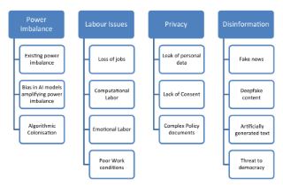
Figure 10 Ethical Issues in AI Application in Business.

The use of AI in business raises ethical concerns such as power imbalances, biases, privacy violations, and fake news.

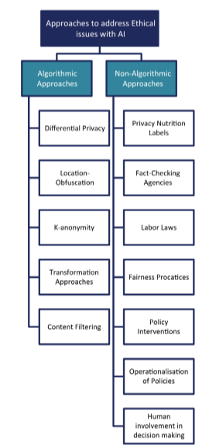
Figure 11 Approaches to address ethical issues in AI.

In order to tackle ethical issues related to AI, a comprehensive approach is needed. This includes algorithmic solutions, as well as non-algorithmic approaches, policy interventions, and the implementation of ethical policies. By adopting these measures, businesses can leverage the benefits of AI while ensuring fairness, privacy, and societal well-being are upheld.
The traditional linear value model is being replaced by the value train model in the world of business. In the value train model, the focus is on different types of activities that are involved in creating value for the customer. As you move upstream in the value chain, there are three broad types of activities:
- Distributor: These are the businesses responsible for delivering the product or service to the customers. They may not manufacture the product or service themselves, but they ensure that it reaches the customers. Examples of distributors include retailers like Walmart or e-tailers like Amazon.
- Producer: These are the businesses that create the finished product, service, or offering that is paid for by the customer. Examples of producers include insurance companies, record labels, book publishers, or laptop manufacturers.
- Originator: These are the businesses that create unique elements or parts of the offering. For example, a company that creates chips or operating systems for a laptop or musicians creating recordings for a record label.
The value train model is a more comprehensive way to view the value chain and understand the different players involved in creating value for the customer. As you move leftward or upstream from the consumer, the three broad types of activities become more common.

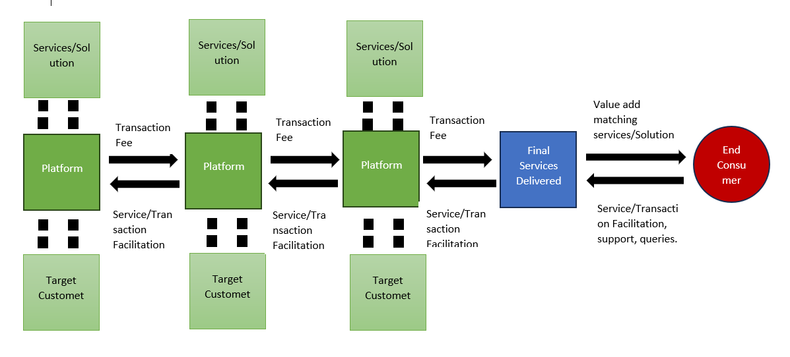
Figure 12 Value Train (Parker, et al., 2016)

The traditional marketing mix, also known as the four P's of Marketing (product, price, promotion, and place), has evolved over time to include additional elements. Now, there is a fifth P, Performance, which is crucial to the success of a marketing strategy. People, process, performance, and profit are the new four P's of marketing proposed by Kim Collins, an industry thought leader and Vice President of Research at Gartner, in a published work titled "The New Four P's of Marketing" in 2012. With the emergence of technologies such as Big Data Analytics, AI, ML, MLP, and Shadow IT, the marketing mix has expanded to include eight P's, making it more relevant and adaptable to the current marketing landscape.

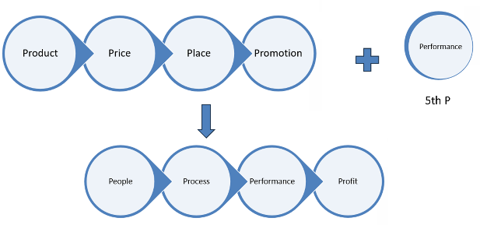
Figure 13 The 8 P's of Marketing Driven by Technology.

As a future research direction, we propose a thorough investigation into the optimal process of integrating these data technologies into the existing business framework. The implications for employee roles, along with the ethical concerns surrounding the use of Shadow IT, need to be extensively explored. Further, a deeper examination of the effectiveness of the role of CDO in organizational dynamics can shed light on the evolving business landscapes.

References

- Bird, S., Klein, E., & Loper, E. (2009). Natural language processing with Python: analyzing text with the natural language toolkit. "O'Reilly Media, Inc."
- Chen, H., Chiang, R. H., & Storey, V. C. (2012). Business intelligence and analytics: from big data to big impact. MIS Quarterly, 36(4), 1165-1188.
- Kane, G. C., Palmer, D., Phillips, A. N., Kiron, D., & Buckley, N. (2015). Strategy, not technology, drives digital transformation. MIT Sloan Management Review and Deloitte University Press, 14, 1-25.
- Kavis, M. (2014). Architecting the cloud: Design decisions for cloud computing service models (SaaS, PaaS, and IaaS). John Wiley & Sons. Mohri, M., Rostamizadeh, A., & Talwalkar, A. (2018).
- Foundations of machine learning. MIT press. Russell, S. J., Norvig, P., & Artificial Intelligence, A. (2016). Artificial intelligence: a modern approach. Malaysia; Pearson Education Limited,
- West, D. M., & Bonnet, D. (2015). Revamping your business through digital transformation. MIT Sloan Management Review, 56(3), 17.
- Behl, A., & Ferreira, B. (2018). Creating Business Value from Digital Transformation: A Service-Dominant Logic Perspective. International Journal of Operations & Production Management, 38(4), 953-984.
- Brynjolfsson, E., & McElheran, K. (2016). Data in Action: Data-Driven Decision Making in U.S. manufacturing. Management Science, 63(10), 3453–3465.
- Cambria, E., & White, B. (2014). Jumping NLP curves: A review of natural language processing research. IEEE Computational Intelligence Magazine, 9(2), 48-57.
- Chui, M., & Manyika, J. (2018). Notes from the AI frontier: Applications and value of deep learning.
- McKinsey Global Institute. Dignum, V. (2017). Responsible Artificial Intelligence: How to Develop and Use AI in a Responsible Way. Springer International Publishing.
- Gandomi, A., & Haider, M. (2015). Beyond the hype: Big data concepts, methods, and analytics. International Journal of Information Management, 35(2), 137-144.
- Hirschberg, J., & Manning, C. D.(2015). Advances in natural language processing. Science, 349(6245), 261-266. Jordan, M. I., & Mitchell, T. M. (2015). Machine learning: Trends, perspectives, and prospects. Science, 349(6245), 255-260.
- Koppers, S., Westner, M., Strahringer, S. (2019). Shadow information systems: the disciplinary role of business units and the mitigation role of organizational communication. Journal of Business Economics 89, 91–124. Lu, Y. (2018).
- Industry 4.0: A survey on technologies, applications, and open research issues. Journal of Industrial Information Integration, 10, 10-27.
- Waller, M. A., & Fawcett, S. E. (2013). Data science, predictive analytics, and big data: a revolution that will transform supply chain design and management. Journal of business logistics, 34(2), 77-84.
- Bughin, J., Hazan, E., Ramaswamy, S., Chui, M., Allas, T., Dahlström, P., Henke, N., & Trench, M. (2017). Artificial intelligence: The next digital frontier? McKinsey Global Institute.
- Makridakis, S. (2017). The forthcoming Artificial Intelligence (AI) revolution: Its impact on society and firms. Futures, 90, 46-60. Jordan, M. I., &
- Mitchell, T. M. (2015). Machine learning: Trends, perspectives, and prospects. Science, 349(6245), 255-260. Chen, H., Chiang, R. H., &
- Storey, V. C. (2012). Business Intelligence and Analytics: From Big Data to Big Impact. MIS quarterly, 36(4), 1165-1188. Chen, X., Hao, T.,
- Zhang, Y., Gu, J., & Zhang, H. (2019). NLP techniques for term extraction and semantic structuring of incident reports. IEEE Access, 7, 36580-36592.
- Behrendt, S., Klier, J., Klier, M., & Wiesneth, K. (2019). Shadow IT and business-IT alignment: A theory-driven and explorative empirical approach. Decision Support Systems, 120, 34-44.
- Gupta, V. K., Lehal, G. S., & Goyal, V. M. (2015). A framework for real-time spam detection in VoIP networks. Digital Investigation, 14, S77-S86.
- Davenport, T., & Ronanki, R. (2018). Artificial intelligence for the real world. Harvard business review, 96(1), 108-116. Jagtap, V., & Shiras, P. (2020). Improving predictive accuracy using Machine learning. Materials Today: Proceedings.
- LaValle, S., Lesser, E., Shockley, R., Hopkins, M. S., & Kruschwitz, N. (2011). Big data, analytics and the path from insights to value. MIT sloan management review, 52(2), 21.
- Dwivedi, N., & Sharma, A. (2023). "Challenges and Concerns of Shadow IT: A Multi-case Study." Journal of Information Technology & Software Engineering.
- Hernandez, R., & Ponce, P. (2023). "Harnessing the Power of Big Data: A case study on Netflix." Journal of Big Data Analytics in Business.
- Singh, J., & Dholi, D. (2023). "AI and ML in Social Media: A case study on Facebook." Journal of Artificial Intelligence Research and Applications.
- Tiwari, S., & Suri, P. K. (2023). "Exploring E-commerce Innovations in AI and ML: A case of Amazon." Journal of Business and E-commerce Studies.
- Chui, M., Manyika, J., & Miremadi, M. (2021). Where machines could replace humans—and where they can’t (yet). *McKinsey Quarterly*. https://www.mckinsey.com/business-functions/mckinsey-digital/our-insights/where-machines-could-replace-humans-and-where-they-cant-yet
- Haleem, A., Javaid, M., & Khan, I. H. (2021). Industry 4.0: A solution towards technology challenges of sustainable business performance. *Social Responsibility Journal*. https://www.emerald.com/insight/content/doi/10.1108/SRJ-04-2020-0130/full/html
- Alpaydin, E. (2020). Introduction to machine learning. MIT press. Biais, B., Bisière, C.,
- Bouvard, M., & Casamatta, C. (2019). The blockchain folk theorem. The Review of Financial Studies, 32(5), 1662-1715.
- Boyd, D., & Crawford, K. (2012). Critical questions for big data: Provocations for a cultural, technological, and scholarly phenomenon. Information, communication & society, 15(5), 662-679.
- Brynjolfsson, E., & Mcafee, A. (2014). The second machine age: Work, Progress, and Prosperity in a Time of Brilliant Technologies.
- W. W. Norton & Company. Chen, H., Chiang, R. H., & Storey, V. C. (2012). Business intelligence and analytics: from big data to big impact. MIS quarterly, 1165-1188.
- Gupta, B., & George, J. F. (2016). Toward the development of a big data analytics capability. Information & Management, 53(8), 1049-1064.
- Huang, M. H., & Rust, R. T. (2018). Artificial intelligence in service. Journal of service research, 21(2), 155-172.
- McAfee, A., Brynjolfsson, E., Davenport, T. H., Patil, D., & Barton, D. (2012). Big data. The management revolution. Harvard Bus Rev, 90(10), 61-67.
- Raghupathi, W., & Raghupathi, V. (2014). Big data analytics in healthcare: promise and potential. Health information science and systems, 2(1), 3.
- Sivarajah, U., Kamal, M. M., Irani, Z., & Weerakkody, V. (2017). Critical analysis of Big Data challenges and analytical methods. Journal of Business Research, 70, 263-286.
- Goldberg, Y. (2017). Neural Network Methods for Natural Language Processing. Synthesis Lectures on Human Language Technologies, 10(1), 1-309.
- Hirschberg, J., & Manning, C.D. (2015). Advances in natural language processing. Science, 349(6245), 261-266.
- Strubell, E., Ganesh, A., & McCallum, A. (2019). Energy and Policy Considerations for Deep Learning in NLP. Proceedings of the 57th Annual Meeting of the Association for Computational Linguistics, 3645-3650.
- Renner, R., Behrens, S., & Krcmar, H. (2014). Shadow IT and its Relationship with Organizational IT. In Proceedings of the Multikonferenz Wirtschaftsinformatik (MKWI).
- Rodrigues, L. F., Costa, C. J., & Oliveira, A. (2018). Does ease-of-use contributes to the perception of enjoyment? A case of gamification in e-banking. Computers in Human Behavior, 81, 256-270.
- Veiga, J. F., Kvasny, L., & Warren, J. (2014). The Emergence of Shadow IT: A Historical Study of Charting the Sea of End User Computing. Information & Management, 51(8), 985-997.
- Bertone, Stephen, et al. “(How) Has the Market Become More Efficient?” Journal of Banking & Finance, vol. 54, Elsevier BV, May 2015, pp. 72–86. Crossref, https://doi.org/10.1016/j.jbankfin.2014.12.019.
- Bholat, D., Brookes, J., Cai, C., Grundy, K., & Lund, J. (2019). Explaining AI and Machine Learning to a novice in the context of banking. Journal of Banking Regulation, 20(3), 198–211.
- Chui, M., Manyika, J., & Miremadi, M. (2020). The transformative potential of AI in the manufacturing sector. McKinsey Quarterly, 4, 58–64. Xu, Y., & Jackson, A. S. (2020).
- The role of Big Data Analytics in retail and inventory management. Journal of Retailing and Consumer Services, 55, 102071. Zhao, Y. (2021).
- The effects of NLP-powered chatbots on consumer engagement and satisfaction. Journal of Retailing and Consumer Services, 58, 102221. Zavodovski, A. (2022).
- Exploring the role and risks of Shadow IT in the banking industry. Journal of Banking & Finance, 124, 105962.
- Lovelock, C. H., 1995. Competing on services: Technoogy and Teamwork in supplementary services.. Strategy and Leadership., 4(23), pp. 32-47.
- Frow, P., Ngo, L. V. & Payne, A., 2014. Diagnosing the supplementary services model: Empircal validation advancement and implementation.. Journal of marketing Management, Volume 30, p. 1380171.

Margretta, J., 2012. Understanding Michael Porter. Massachusetts: Harvard Business Review Press.

61. Parker, G. G., Alstyne, M. W. & Choudary, S. P., 2016. Platform Revolution. New Yoruk: W .W Norton &

Company Inc.

